Timeline article link
Facts from this article:
- Along with Tara Forest East and Tara Baywood, the projects are part of a five-development plan from developers Sayed Moukhtara and Jay Brown, president and principal engineer at JBPro civil engineering, to bring over 1,000 homes to the area.
- Moukhtara is the developer, names all this properties “Tara ____” after him
- Jay Brown runs a $$$ engineering company, JBPro.
- They have other properties around town and it is not popular
  - Example: Alachua County Commissioner Anna Prizzia said “Again and again and again, it always comes back to Tara projects being the projects that we use as examples of what not to do in this community,” Prizzia said.” link

Quotes about Mill Creek Sink from this link:
- “This, to me, is one of the most sensitive places in Alachua County,” Cornell said. “And if not to protect this, then what are we protecting.”
  - Ken Cornell is an Alachua County Commissioner, he’s the Chair now but when he said this quote he was Vice-Chair
- “Mill Creek is ranked among the top sites for Alachua County’s strategic ecosystems, and Hornsby Spring is ranked second. These ecosystems have been marked by Alachua County as the most important and necessary for protection.” - from the reporter
- “Hofstetter said the proposed stormwater retention ponds are very large for the Tara Forest West plans, increasing the chances of a sinkhole.”
  - Stephen Hofstetter is the Director of the Alachua County Department of Environmental Protection
  - Stormwater retention ponds is what Tara April Special Exception Permit is for. There could be other stormwater ponds planned but I don’t know about that.

The developments sit on a sensitive area, the letter explained, underlied by a vast network of water-filled caves. The county recommended additional geologic studies and, according to Tabor, an independent consulting engineer that met with DaRoza and other city staff “advised these matters should be further investigated.” Link
- 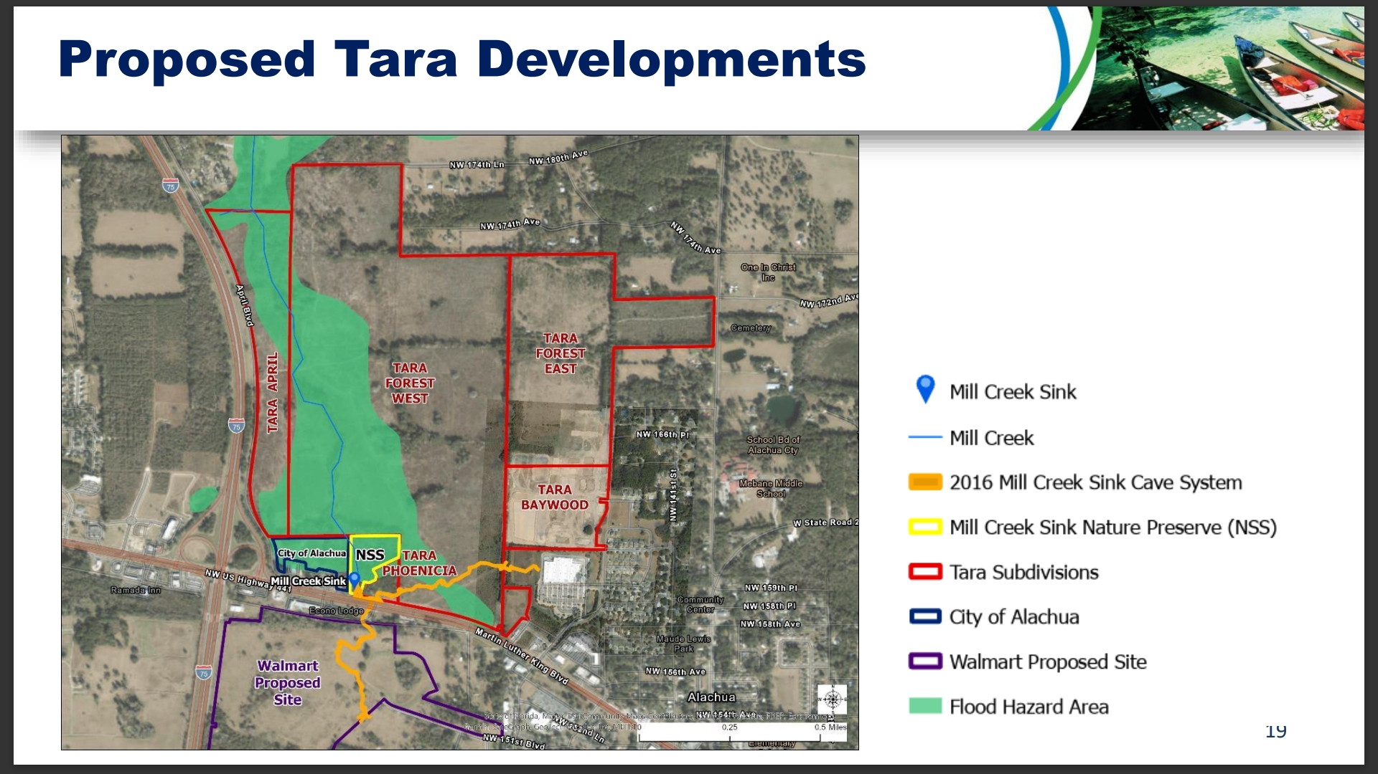

THE PLAYERS:
- Adam Boukari: Former City Manager (before DeRoza) who resigned and started Abbfortis Strategies, a consultant company for developers.
  - His linkedin I won’t click on,
  - Boukari, who spent 12 years with the city in various positions and founded the private consulting firm Abbfortis Strategies after his resignation in August 2021. Link It is said Abbfortis brought Tara Forest to the City instead of selling the land to Conservation. Rude.
  - “The city contracted Adam Boukari to serve as a consultant to the City Manager for six months after his departure, though Tabor alleges his influence outlasted the agreement. Boukari “has been essentially co-managing the City with Mr. DaRoza, while representing developers’ interests in a private capacity,” wrote Tabor.” Link (Tabor is a former planner who resigned, he has a section below)
  - Abbfortis Strategies Sunbiz link, started 7/12/2021
    - Apparently 10 days after he resigned as city manager the first tara application came in, but I have to dig for that back-up if wanted
  - FDLE and FBI story link
    - “According to the FDLE memorandum, Boukari, who is also the former city manager of Alachua, allegedly sexually abused young boys sometime between 2006 and 2021.”
    - Links to another article, basically they were looking for semen samples - link to that back-up
    - “According to a 2016 Gainesville Sun article, Adam Boukari has a longstanding history with SFHS. The Sun reported Boukari “tutors and mentors students, chaperones field trips and has been president of the boy’s basketball Booster Club for seven years.” SFHS is Santa Fe High School
    - On August 27, 2025, TV20 published an article regarding the FBI taking over the SFHS investigation from the FDLE. Thompson reposted the article on his Facebook, and someone commented asking if "the Boukari case [was] dropped." Thompson responded, "Not a chance. It is all pretty much combined at this point, in my opinion."

- [good guy] Justin Tabor: 1 of 3 planners who resigned in early 2025. He is the only one who came out with an open letter to go into detail about Adam Boukari, Mike DeRoza, and pushing the Tara projects around Mill Creek Sink.
  - Justin Tabor’s open letter to the Alachua City Commission
    - This article is where it’s at. In a resigned planners own words, he goes into detail about why Tara April is a problem and why he quit after years of service.
  - Ex-city planner alleges Alachua development was inappropriately rushed through approval process
    - “A City of Alachua planner who resigned last month said he was “being asked to put the interests of a developer above the interests of the public,” in his former role.
    - Justin Tabor alleged City Manager Mike DaRoza disregarded planner recommendations and prematurely pushed developments for approval under the influence of former city manager turned private consultant, Adam Boukari.”
  - The City Commission went from a 5-0 vote to have an investigation into why the planners left and then through 2025, most of them changed their tune. What’s interesting is the only Commissioners who did not change their mind and wanted to find out why they quit were newly elected in April 2025 (Welch and Fletcher). The other three commissioners who were there for the other Tara votes didn’t want an investigation. There’s multiple articles about this at the bottom of https://www.ouralachuawater.org/press-1

- Mike DeRoza, former City Manager
  - Alachua City Manager Mike DaRoza resigns
    - “DaRoza, who has worked for the City of Alachua since 2017 and has served as the city manager since 2022, did not give a reason for leaving.”
    - “DaRoza’s resignation comes just over one week after the Alachua City Commission voted to investigate the resignations of three of its four city planners in February, and before the commission votes formally to proceed with an investigation.”
  - DaRoza had previously served as an assistant to Boukari. Link
  - Tabor’s letter, linked above, goes into detail about how much he wanted to push the Tara developments and the influence from Boukari
- Marian Rush, former City Attorney of 22 years
- After Tabor’s letter came out, Rush had a long comment at the 3/24/2025 meeting where she said she could not believe the city manager deroza would schedule tara hearings without consulting her. Commissioner williams went off on her for insulting the city manager. (link)
- her quote from an article, but the video is juicier lol:
“Rush used her time during attorney comment to go further into detail about cases of quasi-judicial hearings on controversial planning applications where she felt blindsided and was unable to prepare appropriately for the legal proceedings.
- It is a very good video to this nerd. I timestamped it in the links.
Rush said she stands by DaRoza’s intention to do what is best for Alachua without undue influence, but she complained that he does not give her the time she needs to call in experts for contested hearings of applications such as the Tara developments near Mill Creek Sink.
“He’s the fourth city manager, has the least experience, and I hear from him the least,” Rush said. “It should be the exact opposite, because this stuff is technical.” (link)
- Then, she randomly got fired at the end of a commission meeting. Guess who didn’t vote for it? You guessed it, the same two commissioners who wanted an investigation into planner resignations. (Welch and Fletcher) I don’t have the video for this but I can get it. It’s soo shady.
Ready for this one, next?
David Theriaque, the City of Alachua’s land use attorney resigned after Rush was fired. He is really respected so this was a blow.
Scott Walker, attorney for the City of Alachua and High Springs (and others)
- He replaced Marian Rush but he was hired by City Manager, not the Commission which means the Commission can’t fire him like they did to Rush. It was not a public decision at all.
- High Springs is an affected party to Mill Creek Sink development because their water would be affected.
Patrice Boyce
- So because of High Springs affected party status, the City of Alachua hired Boyce to represent them for land use (we can’t get this document because the city wants to charge for public record but she represented the city at a recent city/county meeting).
- Patrice also works for the County in another capacity to represent Alachua County by providing legal advice and counsel to the Wild Spaces Public Places. The county is an affected party to this.
- Unreal: She has also worked for the firm representing the applicant TARA (Stearns Weaver)
City of Alachua Commissioners Williams, Brown, and Ringerson all changed their tune over 2025 to look into planner resignations that happened over 2 weeks. At first they voted 5-0 for it but then eventually Mayor Welch and Commissioner Fletcher couldn’t even get a “second” for a motion. Why?????????? These same 3 commissioners are from the “old guard” and around to vote for any previous Tara and to know Adam Boukari when he was city manager (2021). Based on Tabor’s letter, these resignations were around the same time Tara properties were being pushed through Planning.
Links to commissioner photos: click on each name: https://www.cityofalachua.com/government/city-commission/meet-the-commissioners

